CHAPTER 4: Systems — living connections
Worksheet 4.5

Smoking and diseases
Student: Class:

Cancer and smoking
1. Research by the Cancer Council of NSW has shown that many deaths are directly related to the use of tobacco. The following 2003 data compares the percentage deaths linked to the use of tobacco for some types of cancer in males and females.
Cancer type | Lung | Mouth/pharynx | Oesophagus | Larynx | Bladder | Kidney (pelvis)
Male deaths (%) | 84 | 57 | 54 | 73 | 43 | 55
Female deaths (%) | 77 | 51 | 46 | 66 | 36 | 48
(a) Suggest a reason why the percentage of deaths in each category is lower for women than men.

(b) In 2003, there were 7727 smoking-related deaths. Of these deaths, 6309 were caused by lung cancer. Use the tabulated information to determine whether more men or women died that year of lung cancer.

(c) Use a spreadsheet application to graph the tabulated data in the form of a column graph. Print a hard copy of this graph when you have completed the activity.

Other deaths related to tobacco
2. Cancer is not the only disease related to the use of tobacco. The following pie chart shows the different types of tobacco-related deaths for Australia at the start of the twenty-first century.
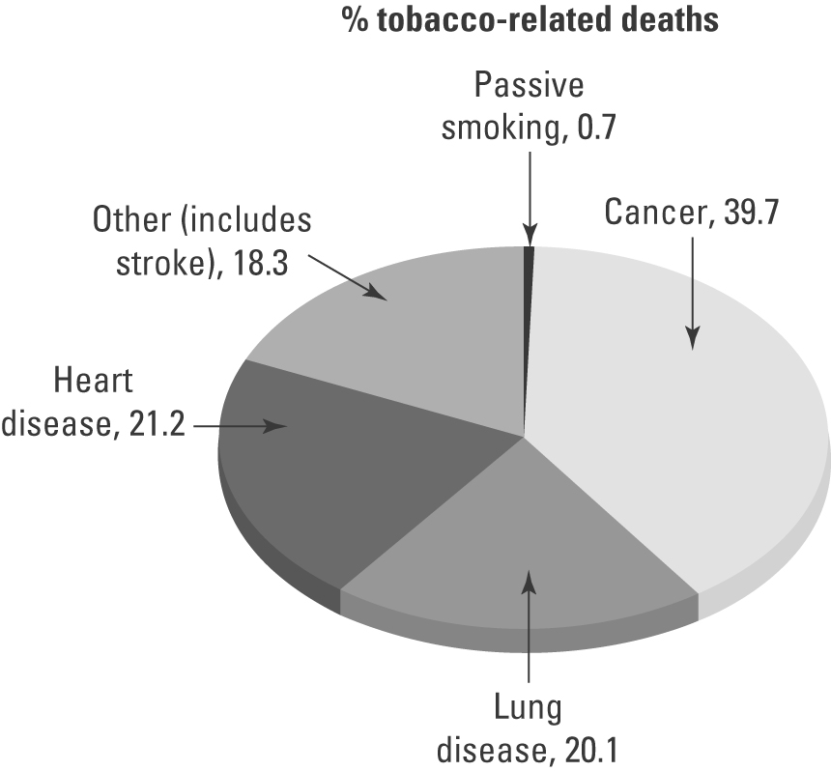 | (a) About 20 000 Australians die each year from tobacco-related diseases. Calculate the number  of those deaths related to:  (i) heart disease  (ii) lung disease.  (b) Explain what is meant by the term ‘passive smoking’.

Nicotine
3. Nicotine is an addictive drug found in tobacco leaves. It is a potent nerve poison. Each cigarette contains about 10 mg of nicotine. Of this, about 2 mg of the drug enters the lungs in the smoke. Many addicted smokers may smoke 25 cigarettes a day. Calculate the mass of nicotine per day that enters:
(a) their lungs
(b) the environment

